Pelvic diaphragm

Introduction
Floor of the true pelvis
Funnel shaped fibromuscular partition in the pelvis

Components of pelvic diaphragm
- Levator ani muscles
- Coccygeus muscles
- Superior and inferior fascia enclosing these muscles

Superior fascia of pelvic diaphragm
Anteriorly - To the body of the pubis and to superior rami of pubis
Laterally - Over the obturator fascia
Posteriorly - With the piriformis fascia and with anterior sacrococcygeal ligament

Inferior layer of pelvic diaphragm
Laterally - Continuous with obturator fascia
Blends with fascia on the external anal sphincter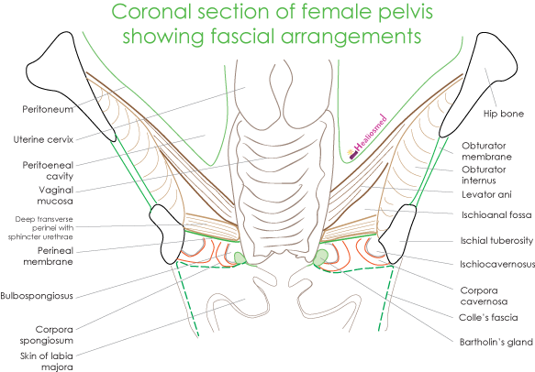

Openings in pelvic diaphragm

Hiatus urogenitalis
Opening between the right and left levator ani muscles
Contains - urethra in males and vagina with urethra in females

Hiatus anorectalis
Opening between the perineal body and anococcygeal raphe
Contains – anorectum

Levator ani
Broad, thin muscle at the pelvic floor
Critical role in pelvic support

Components
- Pubococcygeus
  - Levator prostate in males and
  - Pubovaginalis in females
- Puborectalis
- Iliococcygeus

Pubococcygeus

Origin
From the inner surface of the body of pelvis
From the tendinous arch of obturator fascia

Insertion
Fibres from pubis are inserted into the perineal body
Fibres from the tendinous arch are inserted into the anococcygeal raphe and to the coccyx

Subdivisions

Anteriorly
In males - fibres around the prostate forms - levator prostate
In females - fibres around the vagina and cervix form pubovaginalis
Pubovaginalis - acts as vaginal sphincter

Posteriorly
U shaped sling around the rectum forms puborectalis
Puborectalis blends with the longitudinal fibres of the rectum
[TIP]Puborectalis - creates anorectal angle. It is one of the important factors for the anal continence

Iliococcygeus
Origin:
From the posterior part of the tindinous arch
From the ischial spine (pelvic surface)
Insertion: into the anococcygeal raphe and to the sides of the coccyx

Ischiococcygeus
Origin: apex of ischial spine and sacrospinous ligament
Insertion: coccyx and to the S5 segment of sacrum
Sacrospious ligament - considered as degenerated tendon of the coccygeus

Kegel exercises
Voluntary contractions of all the perineal muscles
Strengthen all the striated muscles in the perineum
Uses -
- Ameliorate erectile dysfunction due to venous leakage
- Help men control premature ejaculation
- Treat urinary incontinence in females
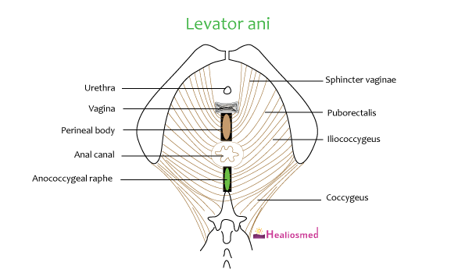

Role of pelvic diaphragm during labour
During 2nd stage of labour, pelvic diaphragm - guides the fetal head descent

Functions of pelvic diaphragm
- Supports the pelvic viscera.
- Elevates prostate.
- Sphincter of vagina.
- Coccygeus pulls coccyx forwards.
- Puborectal sling relaxes to assist defaecation.
- Puborectal sling assists rotation of fetal head.
- Relaxation of pubococcygeus helps in micturition by permitting descent of bladder neck.

Nerve supply
On the pelvic surface - direct branches of ventral rami of S4
On the perineal surface - branches of perineal nerve and inferior rectal nerve
Ischiococcygeus - by branches of S3 and S4

Clinical significance - Levator ani syndrome
Due to intermittent, episodic spasm of the levator ani muscle, patient may experience sharp buring pain or tenesmus of the rectal and/or perineal area

Hiatus of Schwalbe
A gap between the tendinous origin of levator ani & obturator fascia is called Hiatus of Schwalbe.
Pelvic organs may herniate through this gap causing ISCHIORECTAL HERNIAS.

